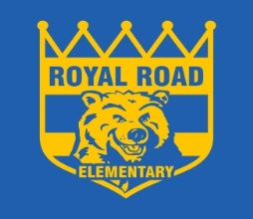 **ROYAL ROAD ELEMENTARY SCHOOL**

340 Royal Road, Fredericton, NB, E3G 6J9

<http://royalroad.nbed.nb.ca>

PHONE: (506) 453-5438

FAX: (506) 444-5268

Sheila Legere *Principal*

Jamie Chiasson *Vice Principal*

November 10th, 2016

Dear Parent/Guardian;

Royal Road School will be selling Royal Road Toques this year. Below you will see a picture of the toque. Orders will be placed on November 18th so please pass in the order form along with payment by the morning of the 18th. The toques are $25.00. You can pay by cash or cheque made out to Royal Road School.

---------------------------------------CUT HERE---------------------------------------------------------

Student Name __________________________

Homeroom Teacher__________________­____

-------------------------------------------------------------------------------------------------------------



 This will actually say RRS and it will be along the front.